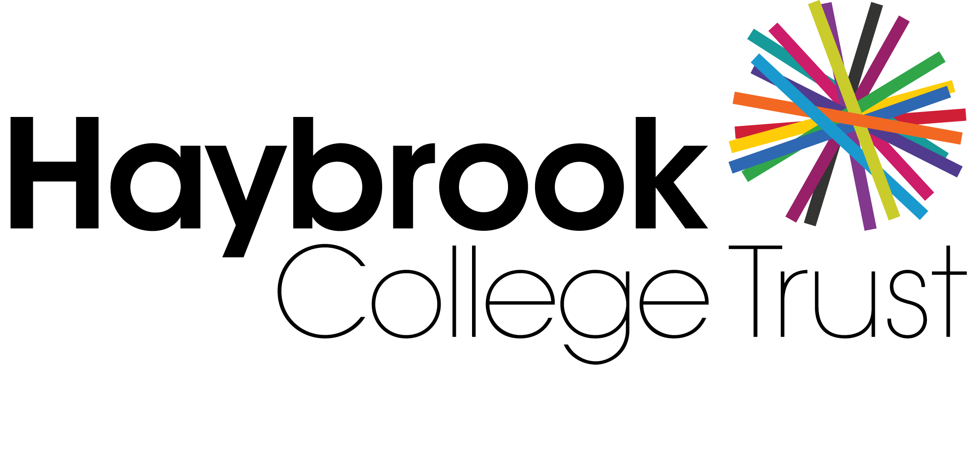

SOCIAL MEDIA POLICY

Date approved:

Date for revision: February 2022

Responsibility: Finance & HR Committee

Approved by full Trustee Board:

__________________________________________________________________________

Table of Contents
- PURPOSE AND SCOPE 3
- POLICY 4
- RESPONSIBILITY 4
- ENFORCEMENT 6
- SOCIAL MEDIA GUIDELINES 6

PURPOSE AND SCOPE

  - Social networking applications provide widespread opportunities to understand engage and communicate with various audiences in innovative and exciting ways. It is essential that this technology and related tools and services are used safely, appropriately and effectively so as to protect and preserve the safety of the pupils and every individual who is part of, or associated with the Trust and its various internal and external communities.

  - It is critical that use of these technologies is effectively balanced with the Trust’s moral and legal duties to the entire Trust community. It is also important that the Trust’s reputation is protected and that a clear framework for best practice exists.

  - The purpose of this Policy is to ensure that:

- All children at the Trust are safeguarded and protected;

- All employees understand the standards that social media users are required to observe, the circumstances in which this media will be monitored and the action that will be taken if the required standards are not met;

- The Trust is not exposed to legal or other detrimental risks;

- The reputation of the Trust is preserved and maintained;

- Employees do not spend unreasonable amounts of working time using Trust facilities, or their own personal devices during their working hours for personal reasons;

- Employees use the correct form of communication when dealing with any Trust related matter;

- Employees maintain a clear line between their private and professional lives;

- Employees and the public are able to clearly understand whether or not information, which is provided via social media applications, is legitimately representative of the Trust.

  - This Policy meets the requirements of relevant legislation and also reflects the Department for Education Guidance for Safer Working Practice for Adults Working with Children and Young People (hereafter known as the DfE Guidance).

  - This Policy applies to all employees of Haybrook College Trust, (referred to in this document as the ‘Trust’).

  - This policy applies to all Employees and other persons who work at or with the Trust or act on its behalf in any capacity. For the avoidance of repetition, these groups will be referred to throughout this policy as ‘Employee/s’.

  - Where this policy makes reference to ‘Children’, this means not only the children who attend the Trust but also any children other than their own immediate relatives. ‘Child’ in this context means anyone below the age of 18.

  - Where this policy makes reference to the ‘Trust Community’ this means all the Trust generally, Employees, pupils, governors, directors, parents of children who attend the Trust or have attended the Trust and external stakeholders.

  - This Policy is not contractual and can be replaced or amended by the Trust from time to time as may be required.

POLICY

  - No social media sites may be used on the Trust premises and neither may Trust computer systems be used to access these sites. The only exception to this is where any form of social media / networking is being used for teaching or other legitimate purposes within Trust with the Head Teacher’s prior approval.

  - Employees who use any social media sites outside of work must refrain from using them in any way that could lead others to consider their conduct unacceptable or offensive. In particular, Employees must neither make adverse comments concerning the Trust Community nor make any comment or disclosure that constitutes a breach of any work related duty of confidentiality.

  - Social networking sites include, but are not limited to: blogs; online discussion forums; collaborative spaces; media sharing devices; or ‘micro blogging’ applications (such Twitter, Facebook, and You Tube).

  - At all times, including times outside of working or contractual hours, Employees must act in accordance with relevant Trust policies (including the Valuing Equality and Dignity at Work Policy, the Disciplinary Policy Safeguarding and child protection policies) and the DfE Guidance.

RESPONSIBILITY

Communications

    - Employees will not invite, accept or engage in any communication with Children on social media sites at any time during the period of their employment at the Trust without first notifying the Head Teacher.

    - Employees will not invite, accept or engage in any communication with parents of children who attend the Trust on social media sites at any time during the period of their employment at the Trust without first notifying the Head Teacher.

    - Any communication received via a social media site from a Child must be immediately reported to the Head Teacher to ensure any relevant safeguarding procedure is followed.

    - If any Employee becomes aware of any inappropriate communication involving a child who is connected with the Trust and any other person whatsoever this must be reported immediately to the Head Teacher. Failure to comply with this paragraph is a breach of the DfE Guidance and will lead to disciplinary action.

Information Posted

    - Employees are responsible for any material they post online which refers to the Trust Community. Employees must maintain professionalism, honesty and respect, and ensure that

they do not make any inappropriate, abusive, hateful or derogatory remarks or statements that may be interpreted as such by others.

    - At no time must photographs or material be published that depicts the Trust setting or children. Pictures of those in the Trust Community may only be used with the express written consent of the individuals concerned.

    - Any Employee who posts remarks or publishes photographs that breach confidentiality or are deemed to be detrimental to the Trust Community will be subject to disciplinary action.

    - Comments that reference the Trust Community must not be published using social media applications unless the Head Teacher has first been notified.

    - Information that Employees do not want in the public domain should not be published using social media applications. Even anonymous posts can often be used to identify individuals. All Employees should remember that material they share through social media applications, even on private spaces, are still subject to copyright, data protection and other legislation.

    - Employees must not use social media applications to publish any material that may result in legal actions for defamation, discrimination, breach of copyright, data protection or other claims for damages from the Trust. This includes, but is not limited to material of an illegal, sexual or offensive nature that may bring the Trust into disrepute.

    - Employees should apply a ‘good judgement test’ for every activity they conduct on line and consider whether or not: it can be viewed by others as a breach of confidentiality; it may be deemed distasteful or a negative representation of themselves or the Trust Community.

    - Employees are reminded that if they have a Facebook account or any other similar social media account they must not make comments that constitute bullying, harassment, defamation, or other inappropriate conduct (or that could be interpreted as such by a third party) or that could bring the Trust into disrepute.

General Responsibilities

    - Employees are required to ensure that their privacy settings are set at maximum and are regularly checked to ensure full protection at all times.

    - Any misuse of the Trust’s facilities e.g. telephone, ICT or mail services, or unjustified excessive time spent on personal activities during their contracted working hours may lead to disciplinary action being taken.

    - Employees who choose to access any social media applications on their personal devices may only do so during breaks and at lunchtime, but not do at any other time when they are contracted to work, whether working in Trust or off site. Personal devices must be switched off during working hours so as to avoid unnecessary distractions.

    - If employees have concerns they wish to raise they should make use of the relevant Trust Policy or Procedure. These will usually be either the Grievance procedure or the Whistleblowing procedure.

ENFORCEMENT

  - The Trust may require the removal of content published by Employees that adversely affects the Trust Community or puts the Trust at risk of legal action.

  - Any online communication published by Employees that is deemed inappropriate for public exchange or causes damage to the Trust Community’s reputation is strictly forbidden.

  - Communications through Internet based websites between an Employee and a child, that is outside of these protocols, may lead to disciplinary and/or criminal investigations.

  - Employees should be aware that without consent, the Trust may monitor or record communications where inappropriate activity involving children is suspected, or in other circumstances where there is reasonable suspicion that an offence is being, or likely to be committed.

  - Breaches of this Policy may be regarded as misconduct, or even gross misconduct for a serious breach and could lead to disciplinary action up to and including summary dismissal.

  - Examples of activities that may be regarded as gross misconduct include but are not limited to:

- Publishing material that discloses the Trust’s web or email address inappropriately;

- Writing anything, which is malicious, defamatory untrue, hurtful, personal or otherwise offensive about the Trust Community;

- Writing anything about the Trust Community that is either a breach of confidential information or which does or is likely to harm, lower or damage the reputation of the Trust Community or adversely affect it;

- Posting any videos, photographs, or any other media which is inappropriate and/or does, or is likely to harm, lower or damage the reputation of the Trust Community or adversely affect it.

SOCIAL MEDIA GUIDELINES

  - There may be occasions where, for legitimate reasons, Employees will need to post information on websites as part of their role. In all circumstances, authorisation from the Head Teacher must be sought before proceeding.

  - Internet activities are not anonymous or secure and can therefore have an impact on the reputation of the Trust. For this reason we expect all Employees who engage with social media on behalf of the Trust to understand and to follow these guidelines.

Rules of Engagement

- Your responsibility – whatever you write is ultimately your responsibility;

- Ensure you are the expert – you are personally responsible for what you write, please ensure you only write and post comments about your areas of expertise/responsibility;

- Where you are not the expert – if your engagement leads to areas outside of your expertise please take advice from the Head Teacher before responding;

- Transparency – it is imperative that when you are using social media as part of your job that you are transparent and honest about who you are and who you work for. Therefore, ensure you use your real name, identify that you work for the Trust and be clear about your role. Never hide behind anonymous or pseudonymous comments;

- Be truthful – anything that you say must be true and not misleading. Any claims or statements you make must be capable of being substantiated and approved. What you publish will be around for a long time, so consider the content carefully and never guess what you think the correct answer may be;

- The Trust’s reputation – remember that by identifying yourself as a Trust Employee, you are creating a perception about the Trust. It is therefore imperative you maintain high standards of English, spelling and grammar;

- Confidentiality – be smart about protecting yourself, your privacy and the Trust’s confidential information. What you publish is widely accessible so consider the content carefully and whether it is sensitive;

- Made a mistake? – if you happen to make a mistake, admit it quickly. If you are posting to a blog, you can modify your earlier post as long as you make it clear that you have done so;

- Monitoring – to protect the reputation of the Trust Community, under the direction of the Executive Teacher, the ICT team may monitor online media to see what is being discussed. A member of SLT or other appropriate person may view communications with or without an Employee’s consent in certain circumstances, which includes cooperating with an external investigation that may take place by the Police or Social Services.

